

➢ ABSTRACT:

The Automobile Management System project involves the development of a comprehensive database system to streamline and enhance the management of car sales operations. The database encompasses tables for cars, customers, sales transactions, dealerships, and inventory. Through structured queries, the project aims to facilitate tasks such as tracking inventory levels, analyzing sales trends, and managing customer interactions. Additionally, it emphasizes the integration of efficient reporting mechanisms to provide key performance indicators and insights for informed decision-making within the car sales domain. The project's overarching objective is to optimize the entire car sales process, from inventory management to customer satisfaction, through effective data organization and analysis.

**“AUTOMOBILE MANAGEMENT SYSTEM”**

➢ AIM OF PROJECT:

The aim of this project is typically to design and implement a relational database system that efficiently manages information related to car sales. This includes storing data about customers, cars, sales. The project should facilitate tasks such as tracking sales, managing inventory, and maintaining customer and vehicle records.

➢ INTRODUCTION:

The Car Sales Management System is a comprehensive database project designed to streamline and organize the operations within a car dealership. This system aims to enhance efficiency in managing customer information, vehicle inventory, sales transactions, and employee records. By leveraging a structured relational database, the project facilitates seamless data retrieval, analysis, and reporting, contributing to informed decision-making and improved customer service.

➢ OBJECTIVE OF PROJECT:

1.Efficient Data Management.

2.Customer Relationship Management.

3.Inventory Control.

4.Sales Transaction Recording.

5.Employee Performance Monitoring.

6.Data Integrity and Validation.

7.Analytical Capabilities.

8.User-Friendly Interface.

**STRUCTURE OF TABLE**

**❖ Cars:**

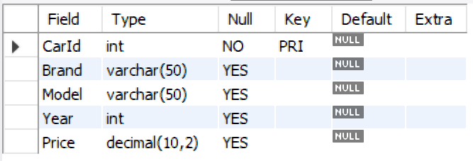

**❖ Customers:**

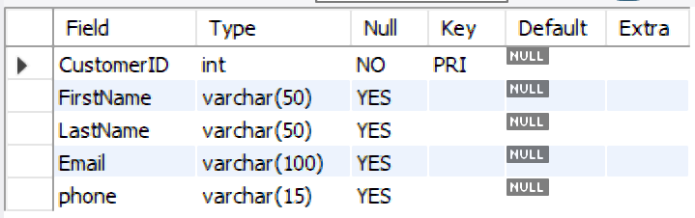

**❖ Sales:**

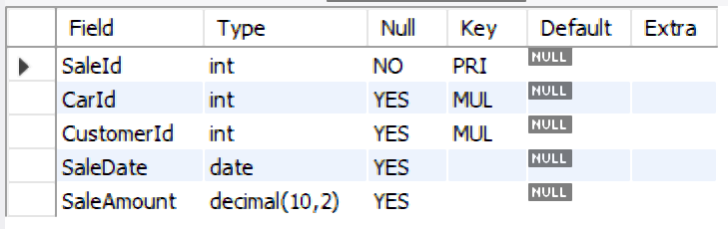

**CONTENT OF TABLES**

**1.Cars:**

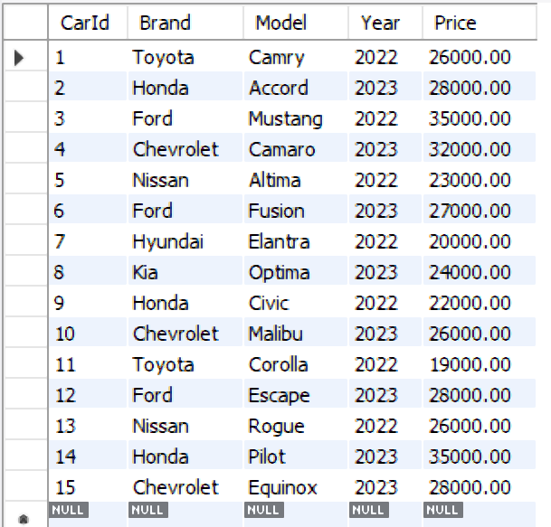

**2.Customers:**

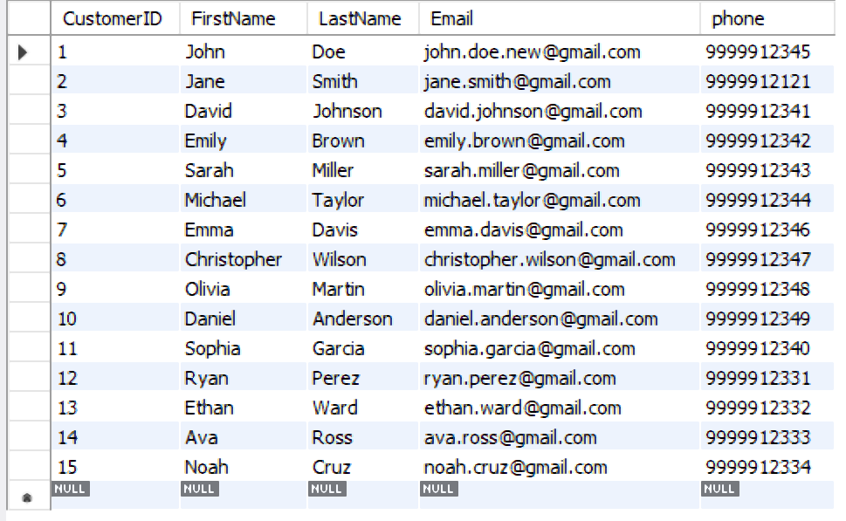

**3.Sales:**

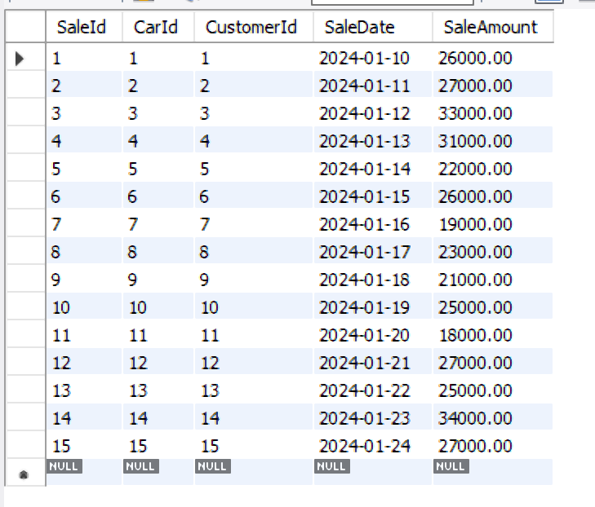

-- **Update Query**

1.UPDATE Cars SET Price = 26000.00 WHERE CarID = 1;

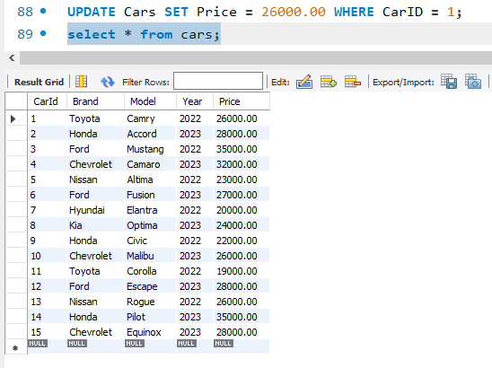

2.UPDATE Customers SET Email= 'john.doe.updated@example.com' WHERE CustomerID = 1;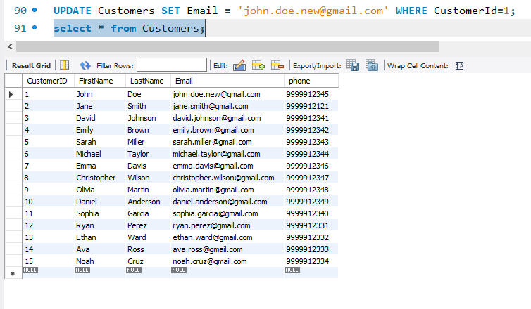

3. UPDATE Sales SET SalePrice = 26000.00 WHERE SaleID = 1;

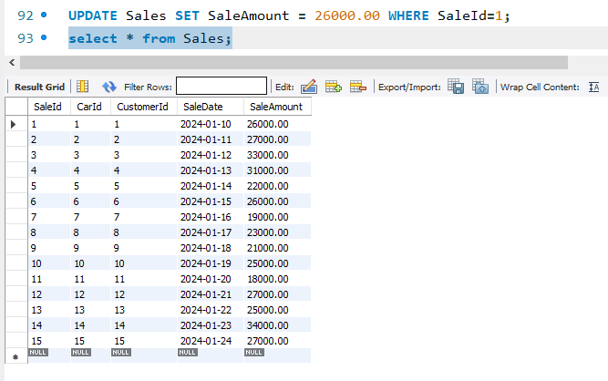

-- **Aggregate Function**

1.Total sales amount

Query:

SELECT SUM(SaleAmount) AS TotalSales FROM Sales;

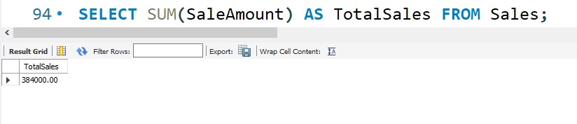

2..Average car price

Query:

SELECT AVG(Price) AS AverageCarPrice FROM Cars;

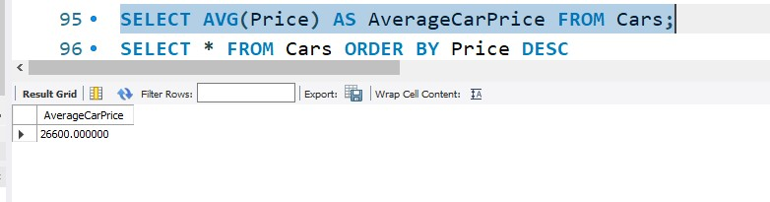

3.Minimum car price

SELECT MIN(Price) AS MinCarPrice FROM Cars;

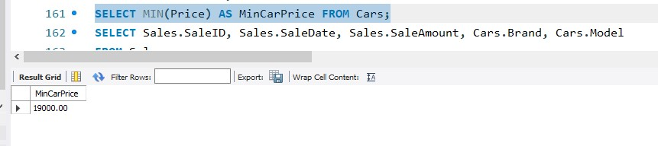

-- Retrieve top 5 most expensive cars

Query:

SELECT * FROM Cars ORDER BY Price DESC

LIMIT 5;

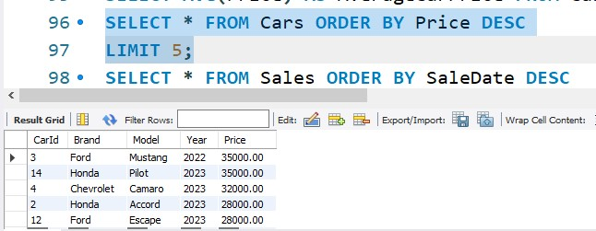

-- Retrieve the 10 latest sales

Query:

SELECT * FROM Sales ORDER BY SaleDate DESC

LIMIT 10;

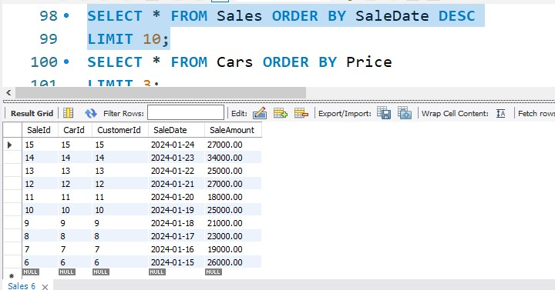

**JOINS**

1.Inner Join:

--Retrieve sales for a specific car brand and model

Query: SELECT * FROM Sales

INNER JOIN Cars ON Sales.CarID = Cars.CarID

WHERE Cars.Brand = 'Toyota' AND Cars.Model = 'Camry';

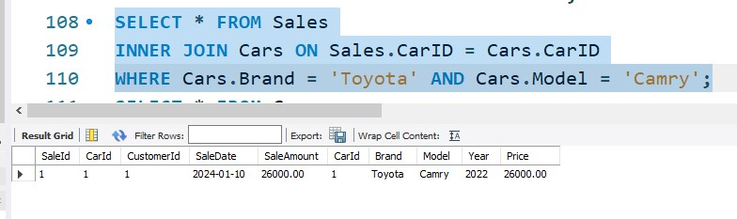

--Retrieve customers who purchased a car in a specific year

Query: SELECT DISTINCT Customers.FirstName, Customers.LastName

FROM Customers

INNER JOIN Sales ON Customers.CustomerID = Sales.CustomerID

INNER JOIN Cars ON Sales.CarID = Cars.CarID

WHERE Cars.Year = 2022;

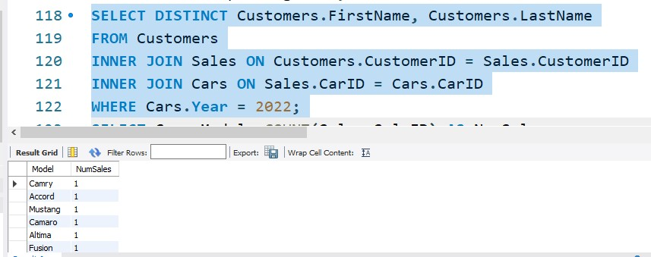

2.Left Join:

--Retrieve Customers with the highest total spending

Query: SELECT Customers.CustomerID, Customers.FirstName, Customers.LastName, SUM(Sales.SaleAmount) AS TotalSpending

FROM Customers

LEFT JOIN Sales ON Customers.CustomerID = Sales.CustomerID

GROUP BY Customers.CustomerID, Customers.FirstName, Customers.LastName

ORDER BY TotalSpending DESC;

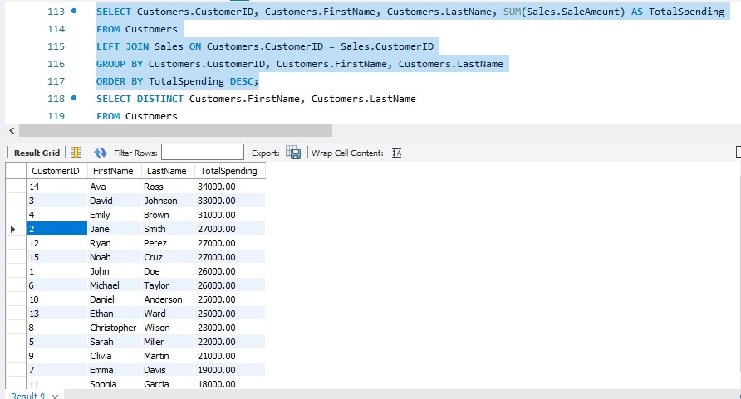

--Retrieve Number of Sales Per Customer

Query: SELECT Customers.FirstName, Customers.LastName, COUNT(Sales.SaleID) AS NumSales

FROM Customers

LEFT JOIN Sales ON Customers.CustomerID = Sales.CustomerID

GROUP BY Customers.FirstName, Customers.LastName;

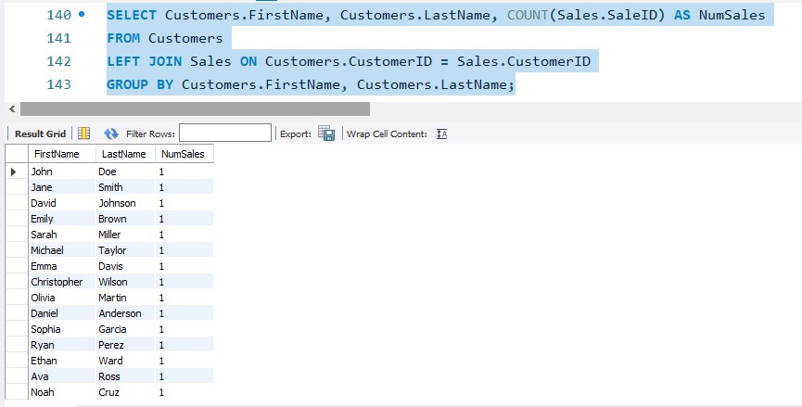

3.Right Join:

Query: SELECT Sales.SaleID, Sales.SaleDate, Sales.SaleAmount, Cars.Brand, Cars.Model

FROM Sales

RIGHT JOIN Cars ON Sales.CarID = Cars.CarID;

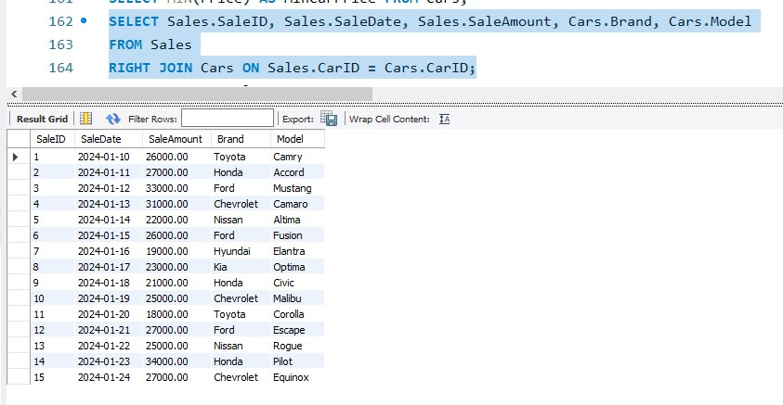

**SUBQUERY**

--Retrieve Sales for Cars Priced Above Average

Query: SELECT * FROM Sales

WHERE CarID IN (SELECT CarID FROM Cars WHERE Price > (SELECT AVG(Price) FROM Cars));

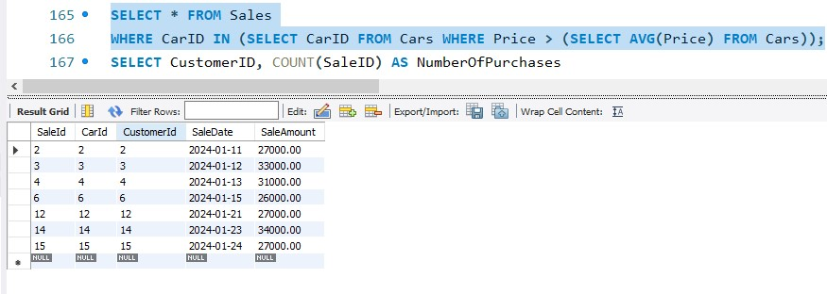

--Retrieve cars with sales count

Query: SELECT Cars.Brand, Cars.Model, (SELECT COUNT(SaleID) FROM Sales WHERE Sales.CarID = Cars.CarID) AS SalesCount

FROM Cars;

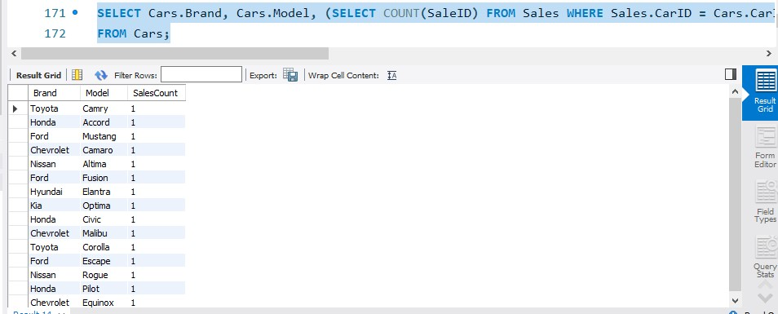

--Retrieve cars with sales count

Query: SELECT * FROM Sales

WHERE SaleAmount = (SELECT MAX(SaleAmount) FROM Sales);

